9

Participant Enrollment Confirmation to Family
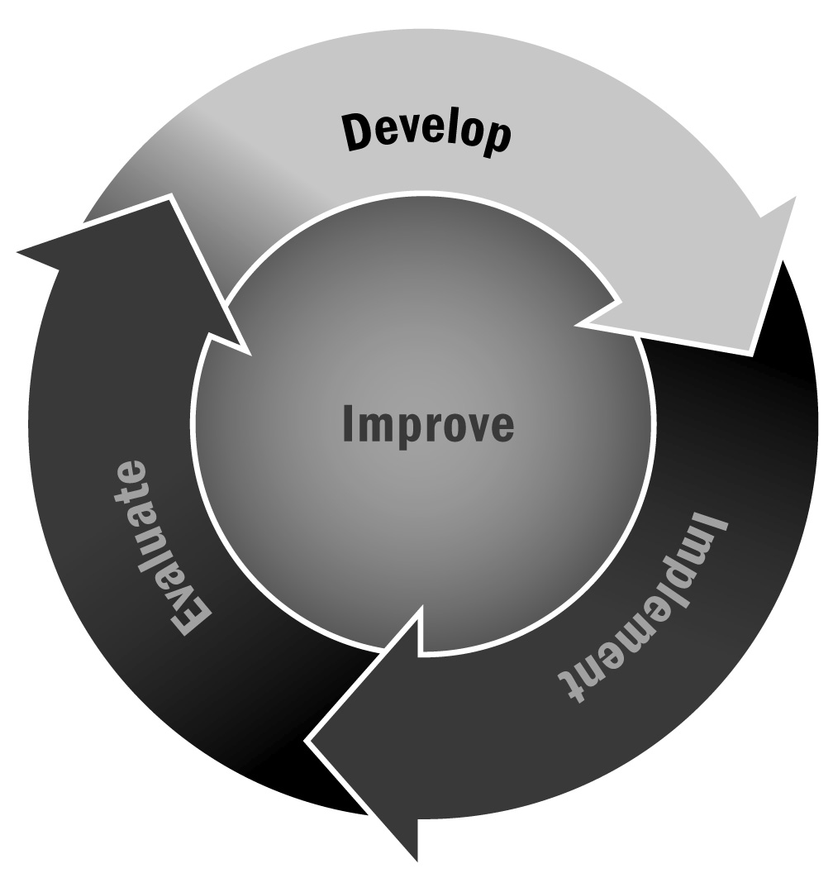
In Chapter 1, you learned that it is important to give family members an information sheet about the program after enrollment so they know what to expect, including when the program starts, attendance policies, and other logistical details.
Directions: You may use or adapt this enrollment confirmation form for your own program. If available, print it on the program letterhead.

To the Family Members of [Name of Young Person]:
This notice is to let you know that your child is enrolled in the [Program Name] at [Organization and Location].
We want to do everything possible to make sure your child has an enjoyable learning experience. We are confirming your child’s start date, program enrollment, instructor, and transportation plan.
[Instructor Name] and the [Program Name] will be prepared for [Name of Young Person] to begin on
[start date]. The program ends on [end date]. We will be off during [list breaks, if any].
Please do not send your child to the program before this date.
Immediately after school, all young people will meet at [name of centralized meeting location for transportation to program, if applicable].
[Name of Young Person] is enrolled in the following activities for this session:
 | Activity | Activity | Activity
Monday
Tuesday
Wednesday
Thursday
Friday

Based on our records, the transportation for your child is:
Transportation Type (e.g., bus, walk) | Time of Departure | Time of Arrival
A family member should accompany younger participants until they are familiar with their new routine.
If for some unforeseen reason your child does not arrive home at the expected time, please call the program/school at [phone number].
We are making every effort to ensure that participants have a fun, safe, and enriching experience.
If you have any questions, please contact us by [phone number] or [email address].

Sincerely,

[Your Name/Program Name]

